Persepolis Writing Assignment: Literary Analysis
Ms. Kamrass; English 10
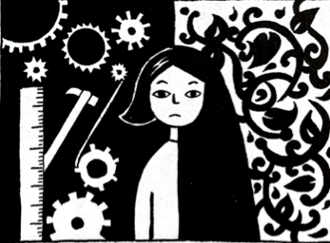
Purpose: Much of your higher education will have you delve into deeper meaning, after ensuring your initial understanding. Literary analysis is one of the most important avenues for developing higher-level thinking. This assignment asks you to think and write about Marjane’s experiences so that you can see more in the book, Marjane (or Marji), Iran, and even the current world around you.

Task: Write a well-developed essay with focused analysis for the graphic novel Persepolis. For this particular lesson, we will focus on improving thesis writing and, as practiced before, the writing process.

To successfully complete this assignment, it is crucial that you are familiar with the novel and use specific, relevant examples.

Topic:
The novel focuses on Marji’s growth from 10-year-old schoolgirl to her 14-year-old self who embarks on a journey (high school outside of her native country). Has Marji reached adulthood?

Guidelines:
- Write at least four (4) paragraphs in the third-person (I, we, you…)
- Craft an interesting introduction. (see the back)
- Incorporate quotations (with page numbers) and at least one literary term in a way that adds to your analysis and doesn’t detract from the flow of the writing.
  - Do not define your literary term.
- Use specifics from the novel: what characters say, what they do, the facts presented, etc.
  - General truths (for example: Marji is rebellious), are needed in the essay, but it is crucial to include the relevant, specific details (also known as Concrete Details) that prove your ideas (for example: Marji hits her school principal).
- Incorporate accurate big ideas – these are all subtopics of your thesis and are usually placed as Topic Sentences and near your specific examples (also known as “Commentary”).
- Write clearly (precise word choice, correct grammar and mechanics, etc.)
- Write in drafts so that you can create your best writing through meaningful revisions
- Use details from the book version, not the film

Check your Weekly Sheets for due dates (first draft, in-class peer review, final copy)

Notes about Introductions:

Yes, rely on hook-TAG-thesis, but…
a. For your hook, refrain from the ordinary, overly general, and cliché (hooks to avoid: Everyone experiences growth…. In today’s world…, etc.).
What should you use for a hook? ______________________________________________

______________________________________________________________________________

b. Title, Author, Genre (TAG) – be specific and integrated so they flow with other information.
c. Briefly include information needed to understand your thesis: general information that sets up your reasoning so that you don’t have to explain too much in the body paragraphs. Sometimes you need specific information, but usually you save it for the body paragraphs.
d. Thesis –This is a statement that you will prove that is usually placed at the end of the introduction. A thesis is your opinion, but it is most often stated as fact. (What to avoid: In my opinion, Marji …).
What should you write for a thesis? See below.

Writing Your Best Thesis Statement
What have you already learned about writing a thesis statement? _________________________
_____________________________________________________________________________
_____________________________________________________________________________
_____________________________________________________________________________
New Notes:

